Adding a New Staff User

1. Navigate to the user management screen by clicking the User Management Tab. A list of your currently registered staff will be displayed.
2. Click on the blue “Add New User” button at the top right-hand side.

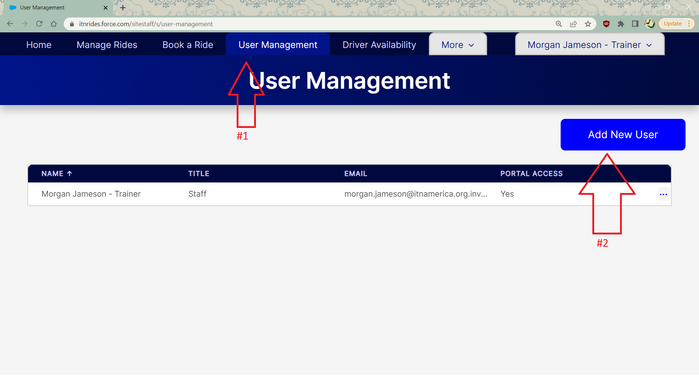

1. A form will pop up to fill out. The following fields are required:
   * First Name
   * Last Name
   * Grant Portal Access? (This should be yes if you want them to have access to the site staff portal to schedule rides)
   * Email Address
   * Type- A person can be more than one type (they may be a paid driver and a staff person)
2. Once you have entered the person’s information, click Save.

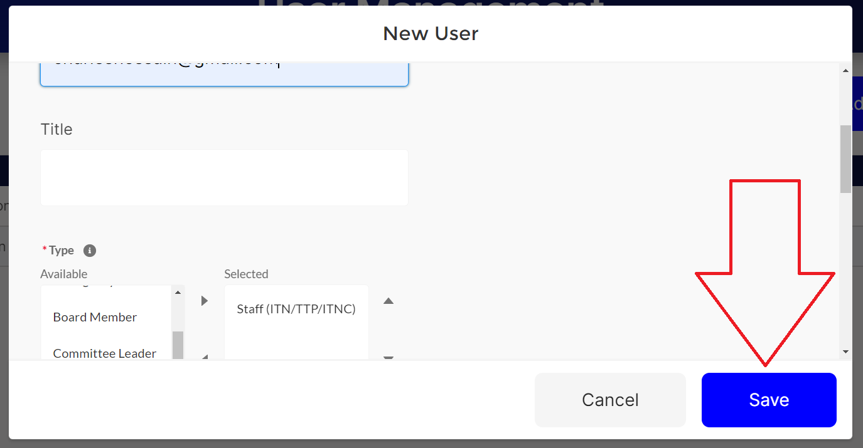

1. A green box will appear to let you know your new staff person has been added successfully, and their name will now appear in the User Management list.