Assigning Drivers to Rides

Ride Matching Batch

1. Make sure your available drivers are accurate and that all available drivers are listed on the Manage Rides page.

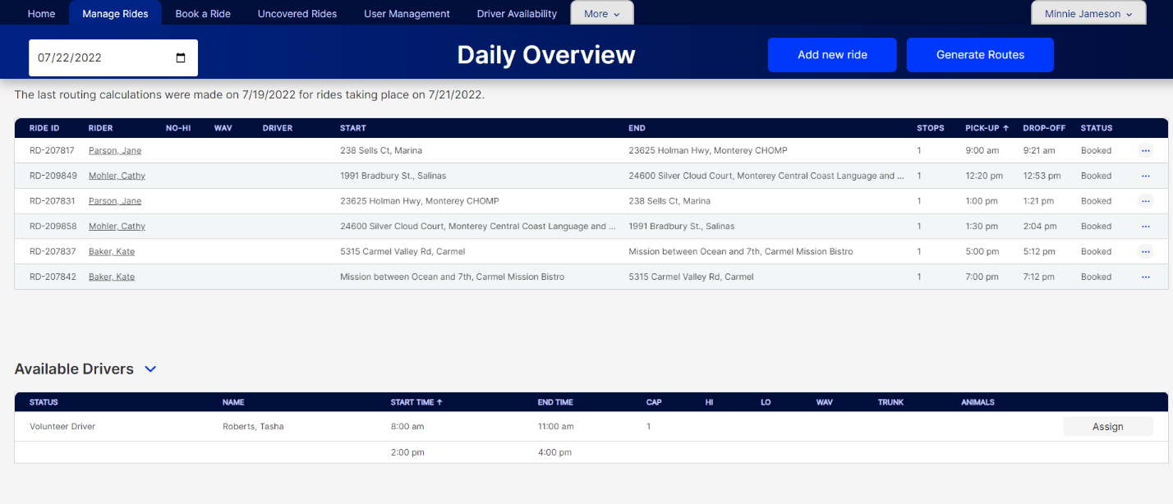

1. Click on Generate Routes at the top of the page. The routes will be generated, with the system assigning the most efficient matching driver to each ride. The routing process can take up to 15-20 minutes to complete, it is not an immediate process.

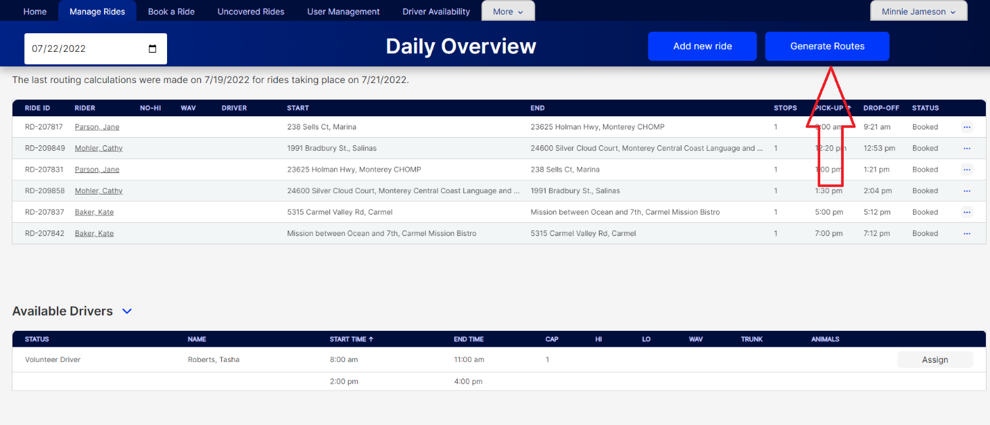

1. The message at the top of the screen will change to let you know when rides have been routed for the day.

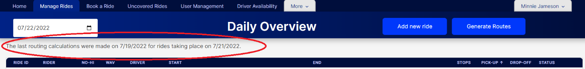

Manually Assigning Drivers

1. Open the Daily Overview by clicking on the Manage Rides tab.
2. Click the carrot next to Available Drivers to show the drivers with availability for the day.

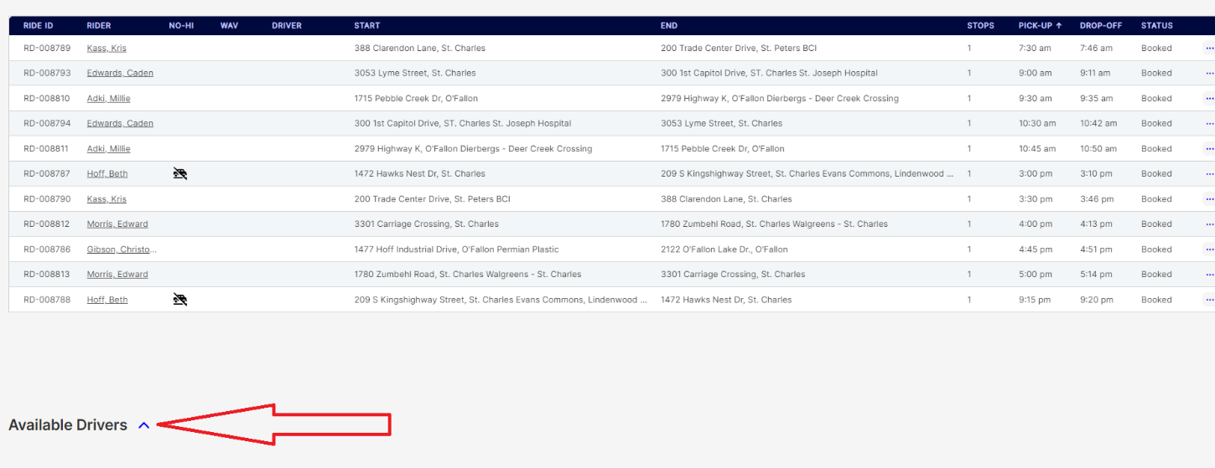

1. The driver list for the day will open. Drivers may have one or two available time periods. If the driver has two time periods available for the day, the second will show just underneath the first.

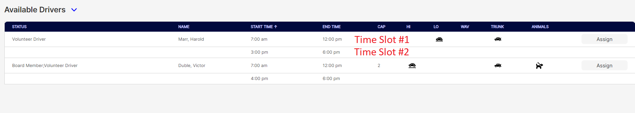

1. Each driver row also indicated the following:
   1. Status- Volunteer or Paid Driver
   2. Name
   3. Start Time- Time the driver is available to begin driving, the first ride assigned to the driver must be after the start time and provide the driver enough time to travel from their start location to the ride location.
   4. End Time- The time the driver must finish driving. The last ride must conclude with enough time for the driver to reach their home location by this time.
   5. Cap- Vehicle capacity or how many people can the vehicle hold.
   6. Hi- Is this is a high vehicle that some riders may have trouble getting into?
   7. Lo- Is this a low vehicle that some riders may have trouble getting into?
   8. WAV- Is this a wheelchair accessible vehicle?
   9. Trunk- Does the vehicle have a trunk?
   10. Animals- Is the driver willing to transport animals?

There will be an icon in the column if that particular condition is true for the driver/vehicle.

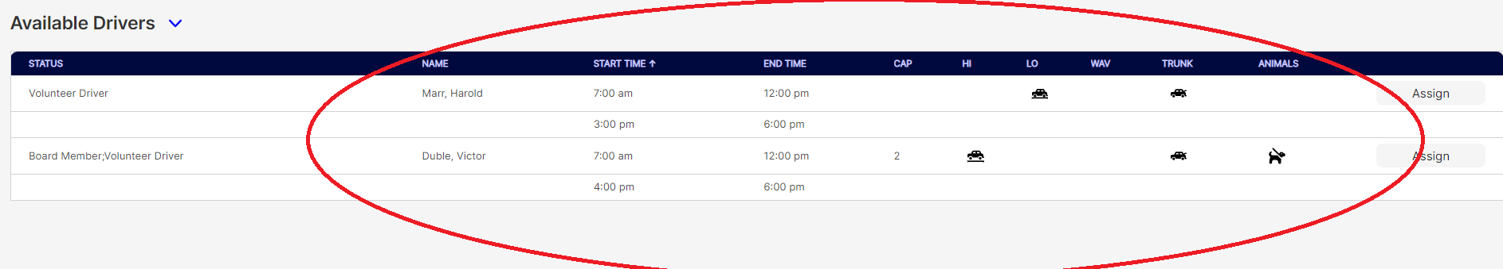

1. To assign a driver to a ride, click on the ride, and then click assign next to the driver’s name. The driver will be assigned to the ride.

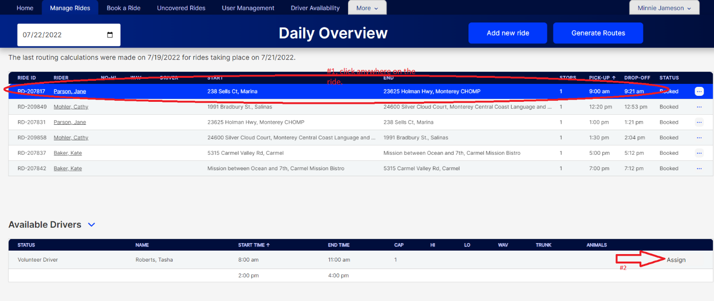

1. After assigning all the drivers, click on Generate Routes near the top of the page so that the system can calculate all of the mileage for the rides. This may cause some of the rides to be reassigned if the system thinks there is a more efficient driver it can schedule.

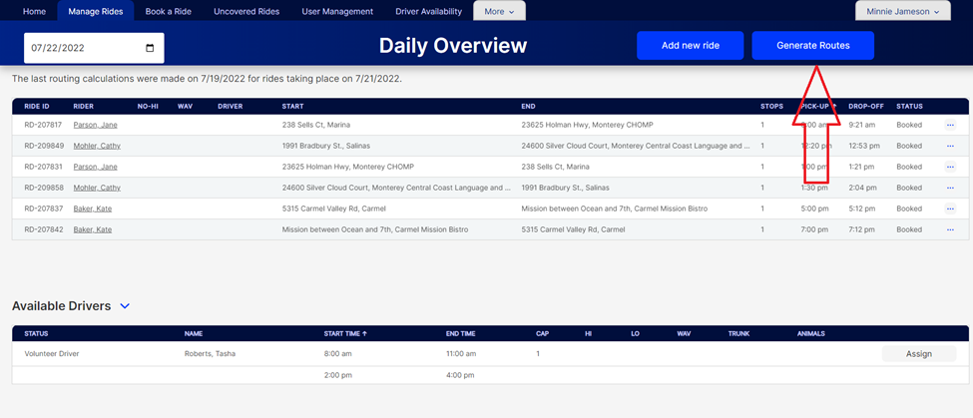

1. Check to see if any rides were changed, and if desired switch the driver back by clicking on the ride and then clicking Assign next to the driver you want for the ride.

