## Changing a Single Membership to a Family Membership

1. Pull up the contact record of the existing single rider. Change the Membership Type to Family.

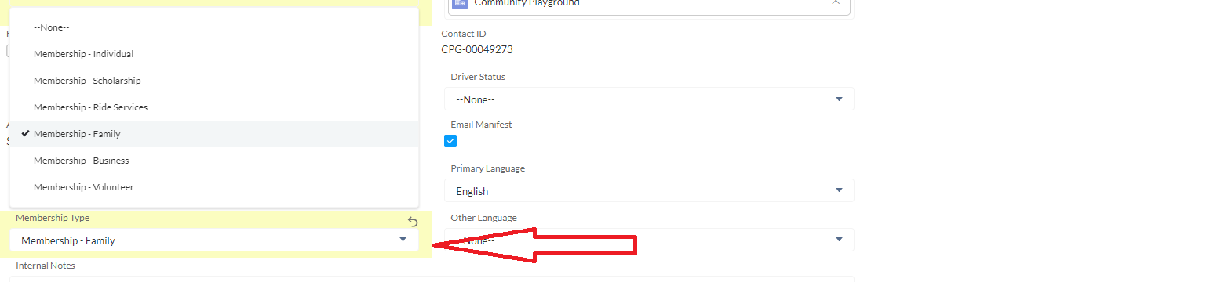

1. Click to open the Account page for the rider, which is labelled PTA.

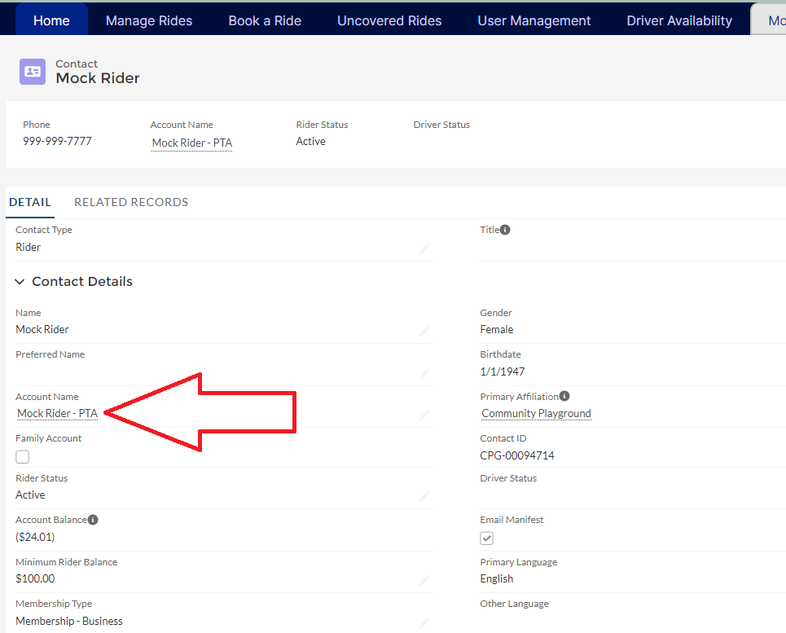

1. Edit the Account to add the name of the second rider. The account name follow the pattern of “Mary and Bob Smith- PTA”. Check off the Family Account box next to the account name and save.

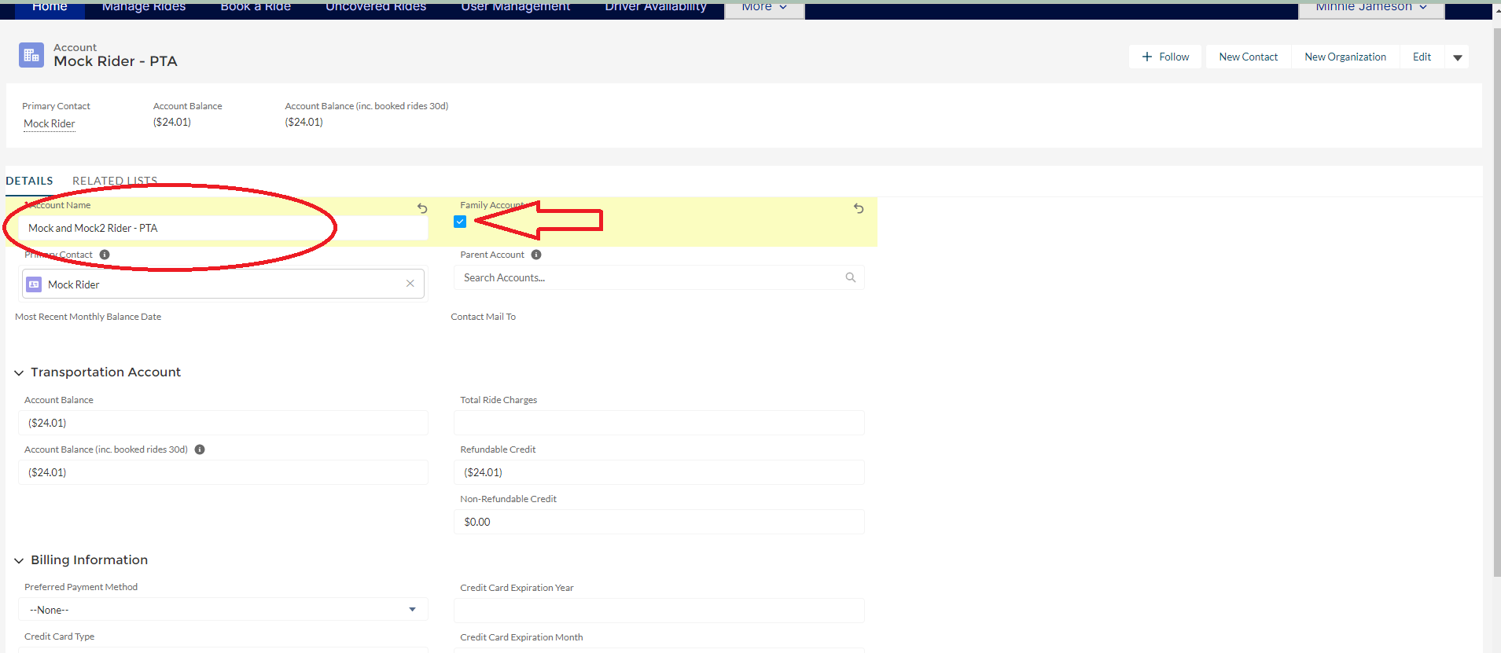

1. Click on the Primary Contact at the top to return to the existing single rider’s Contact Record.

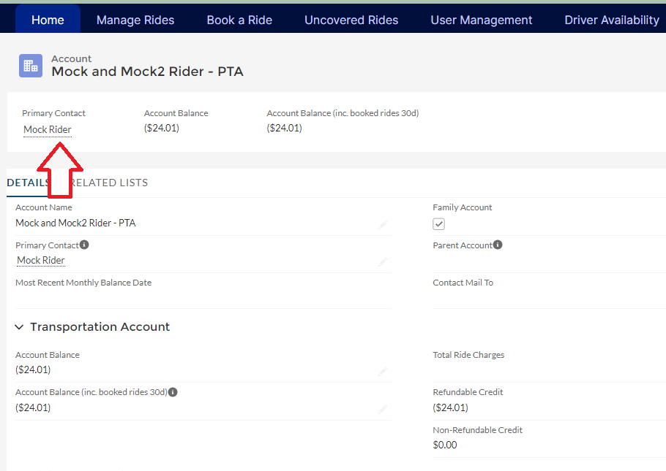

1. You’ll see that the checkbox for Family Account is now checked off.
2. Open the online application (or have the new family member enter their information through the online application), being sure to list the existing member when asked for the name of the 1st Family Member.

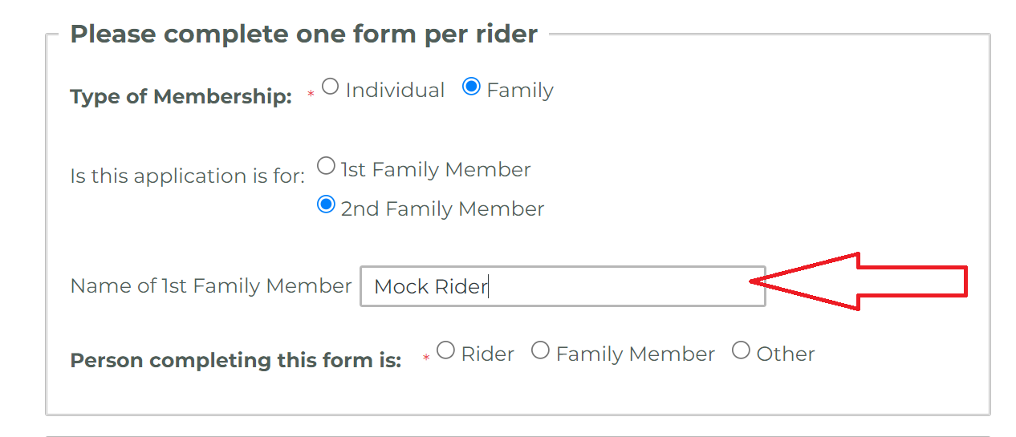

1. Complete the application for the new family member. Once the application is submitted, pull up the Contact Record for the new rider. Make sure to change the Membership Status to Family and the Rider Status to Active.

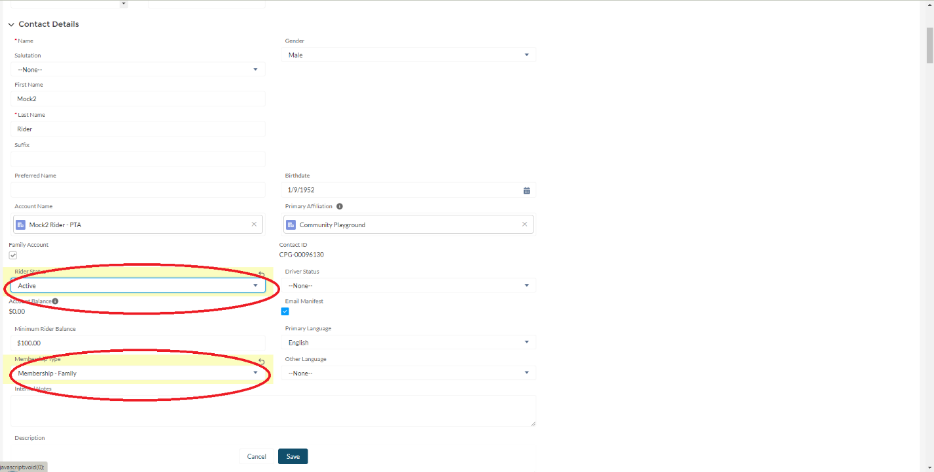

1. Save the new rider’s contact record, and you can now book rides for the new Family Account Member.