## Entering Donors and Other Community Contacts

Donors and other community contacts are entered through the Contacts application. This application contains many field that are not required. The only required fields are:

* Contact Type
* First Name
* Last Name
* City
* State
* Phone (at least one of the following- home, work, or mobile)

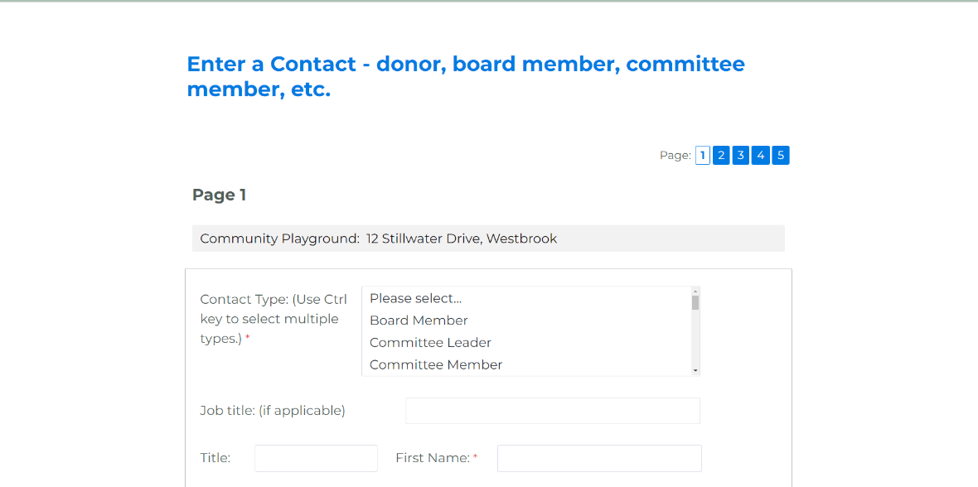

These required fields are all on the first page of the Contact entry form. The next 4 pages capture other information that you may be interested in having on some contacts, but will not apply to all contacts and is not required.