Monthly Posting Report

1. To view the monthly posting report, navigate to the site’s account page. Under the More menu, click on Accounts.

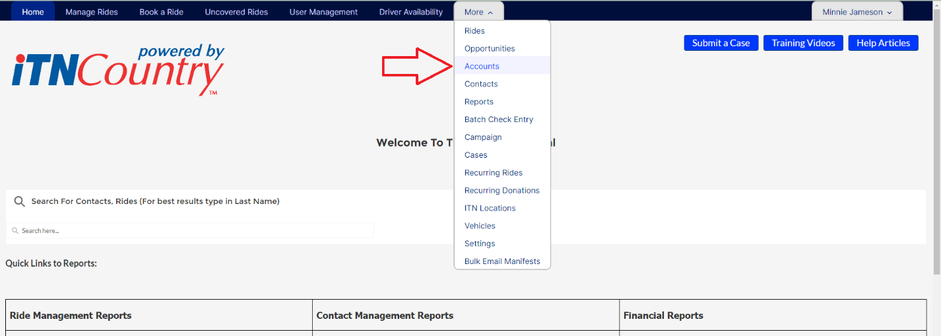

1. On the Accounts list page, choose the Community Accounts view if it is not the default.

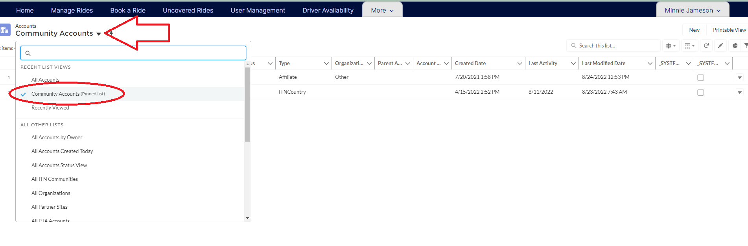

1. Choose your site’s account by clicking on the site’s name.

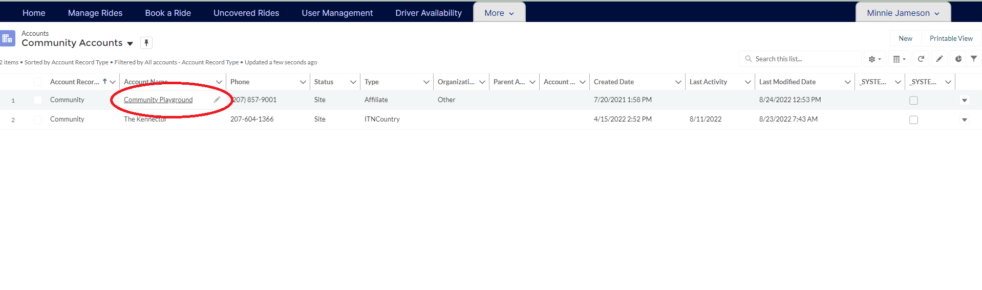

1. On the Account page, click the quick action button at the top right that says Create GL Export. This will download the monthly GL Posting report.

