View Balances and Look Up and Edit Information

Riders

1. On the Home page, type the rider’s name into the search box. The rider’s name will appear below as a Contact.

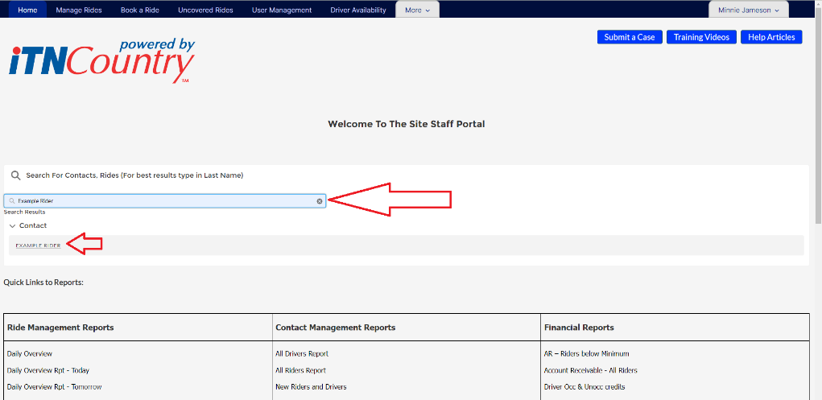

1. Click on the name to open their Contact Record.
2. The quick information bar at the top of the page lists the rider’s phone number and status.
3. The Contact Record page lists all the information about the rider, and you can edit any field that has a little pencil graphic next to it. (The pencils are grayed out until you hover over them, so they can be hard to see at first).

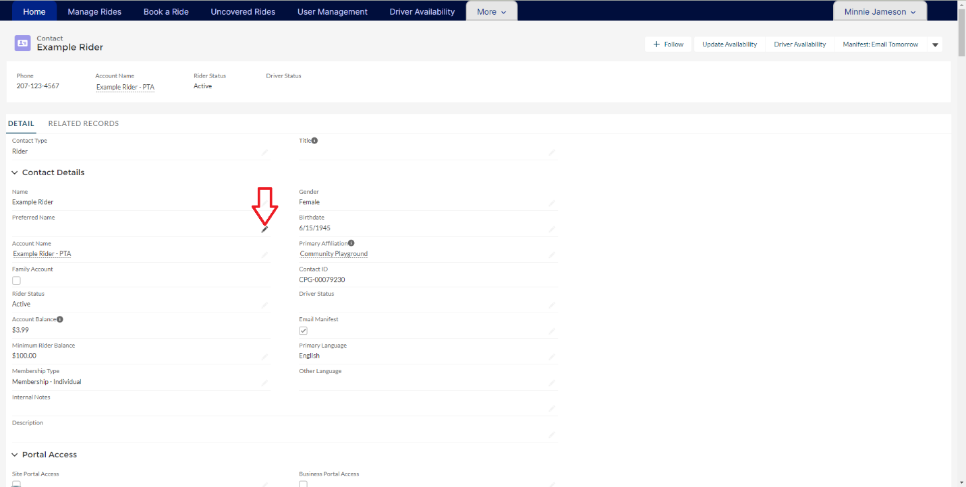

1. The first column contains two tabs- Details and Related.
   1. Details are the personal details of the rider and their contact information.
   2. Related shows their ride history, relationships to other accounts, and payments or donations.

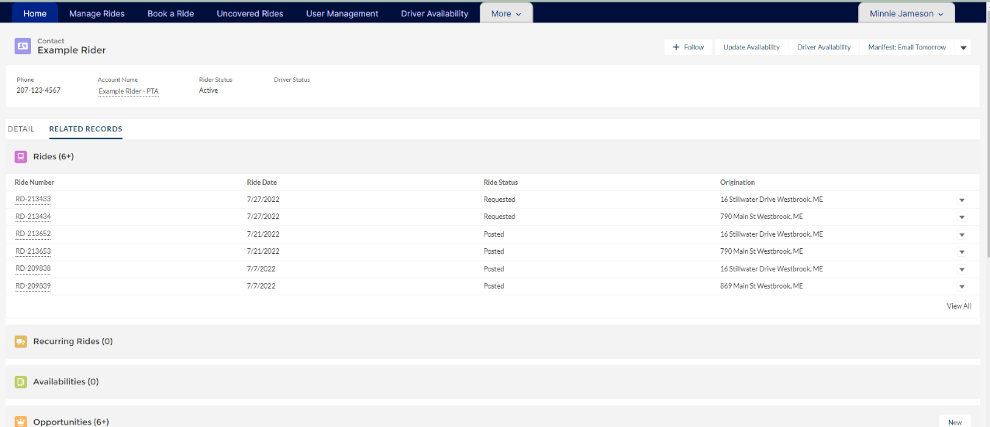

Viewing Customer Accounts (Charges and Payments)

1. Open up the contact record for the rider.
2. Click on the Account in the contact record. The Personal Transportation Account will open.

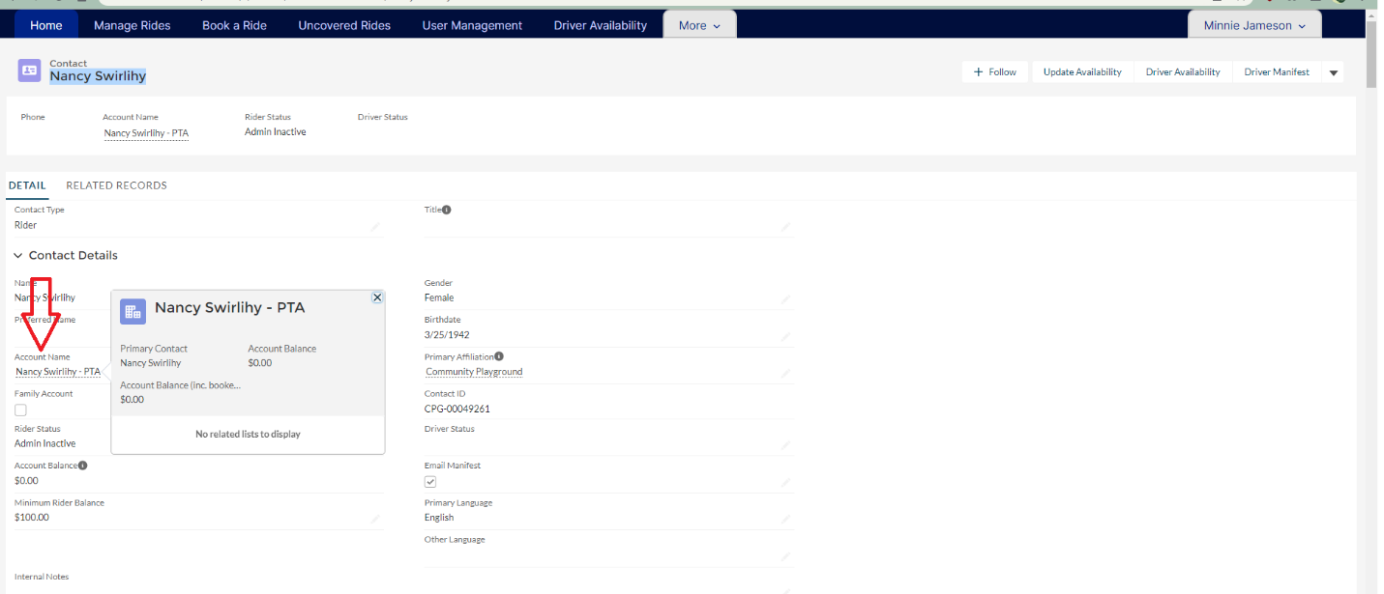

1. Click on related list, and the first item is Transportation Account Items.

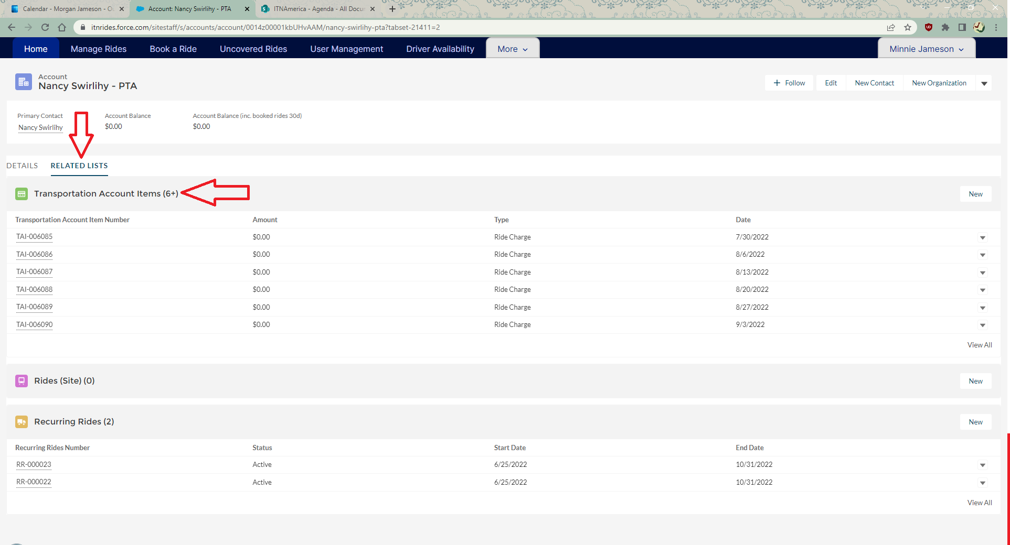

1. Click on View All for the full list.

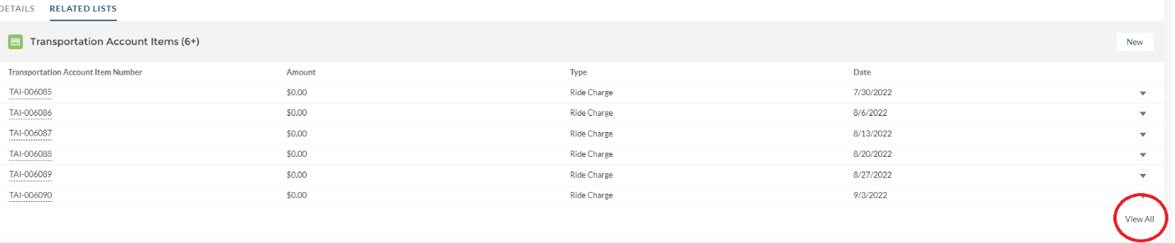

1. Click on the filter to filter by transaction type.

