Rides Requested Through the Rider Portal

Rides requested on the rider portal will show up on the Daily Overview with a “Requested” status. Click on the three dots at the end of the ride’s row to accept or decline the ride.

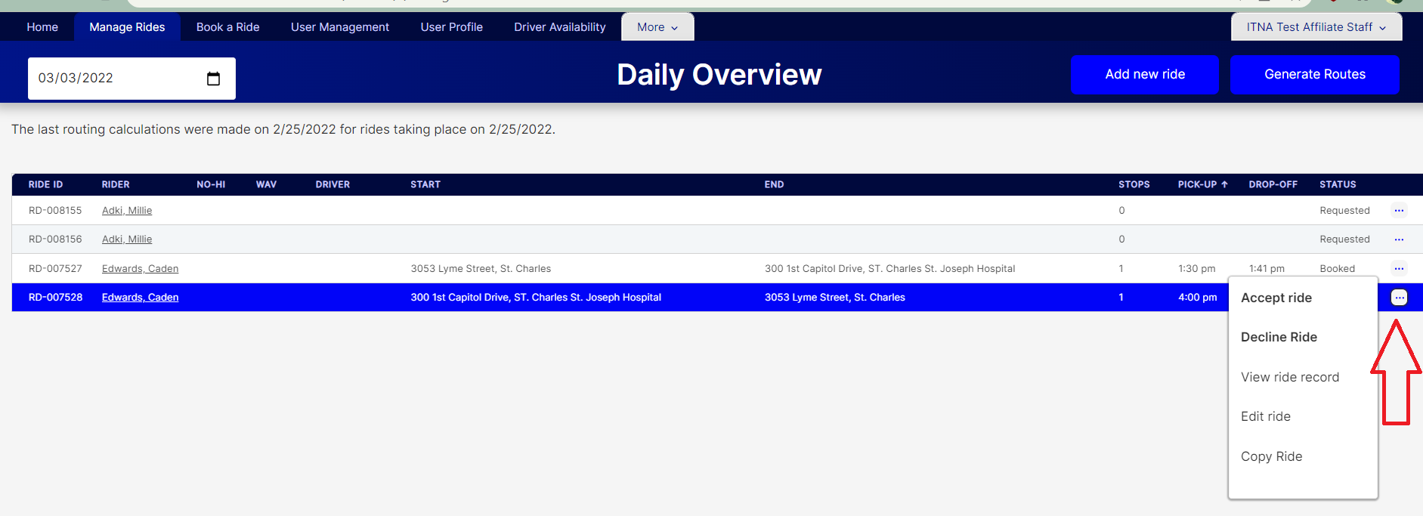

When you accept the ride, the status will change to “Booked”. When the ride is declined, the rider will be sent an email to let them know their request cannot be met.