## To View A Rider’s Account Transactions

1. Open up the contact record for the rider.
2. Click on the Account in the contact record. The Personal Transportation Account will open.

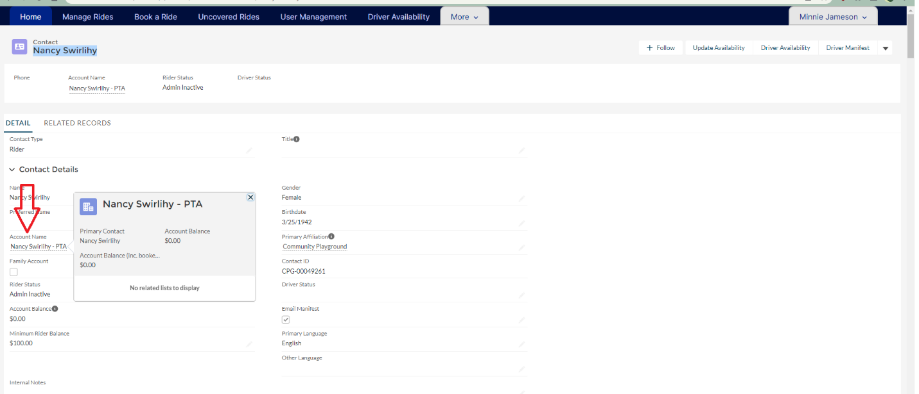

1. Click on related list, and the first item is Transportation Account Items.

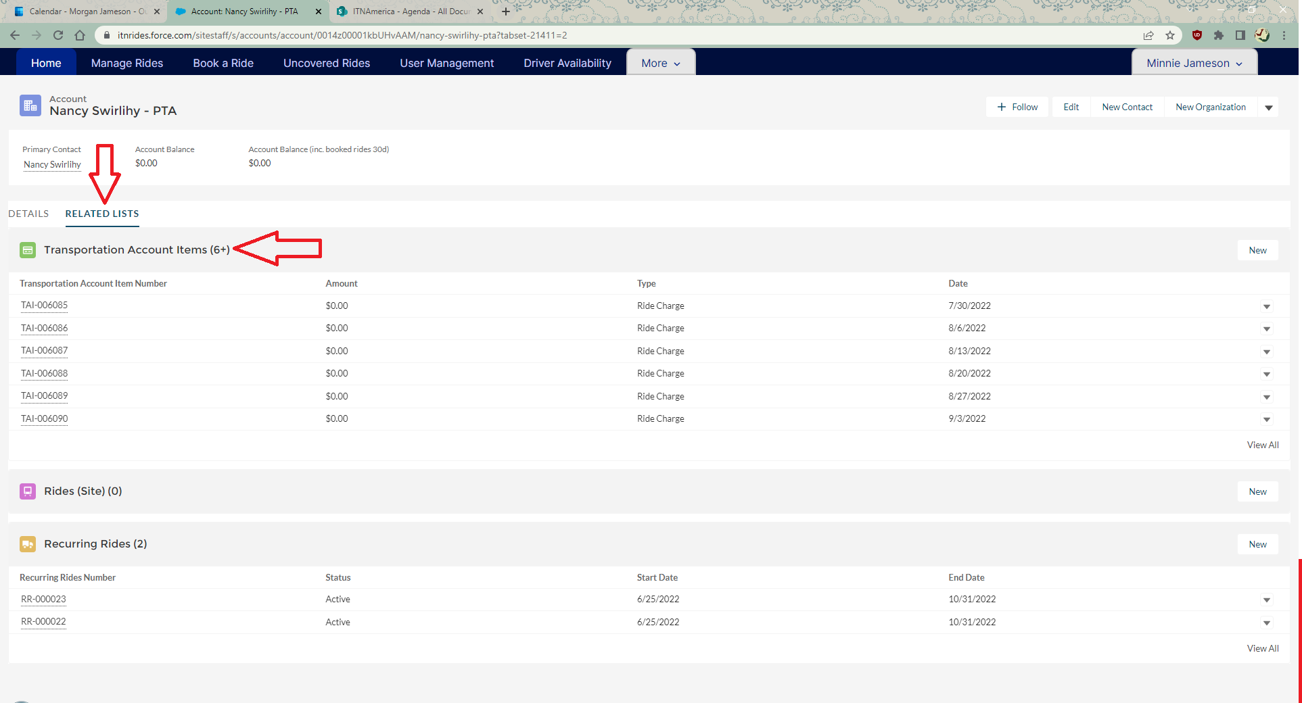

1. Click on View All for the full list.

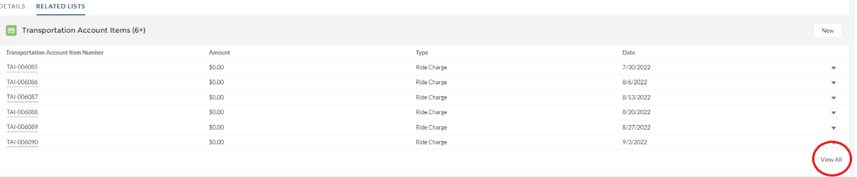

1. Click on the filter to filter by transaction type.

