Closing an Account with No PTA Balance

1. Navigate to the rider’s Contact Record.
2. Change the Rider Status from Active to Closed, and click Save. The account is now closed.

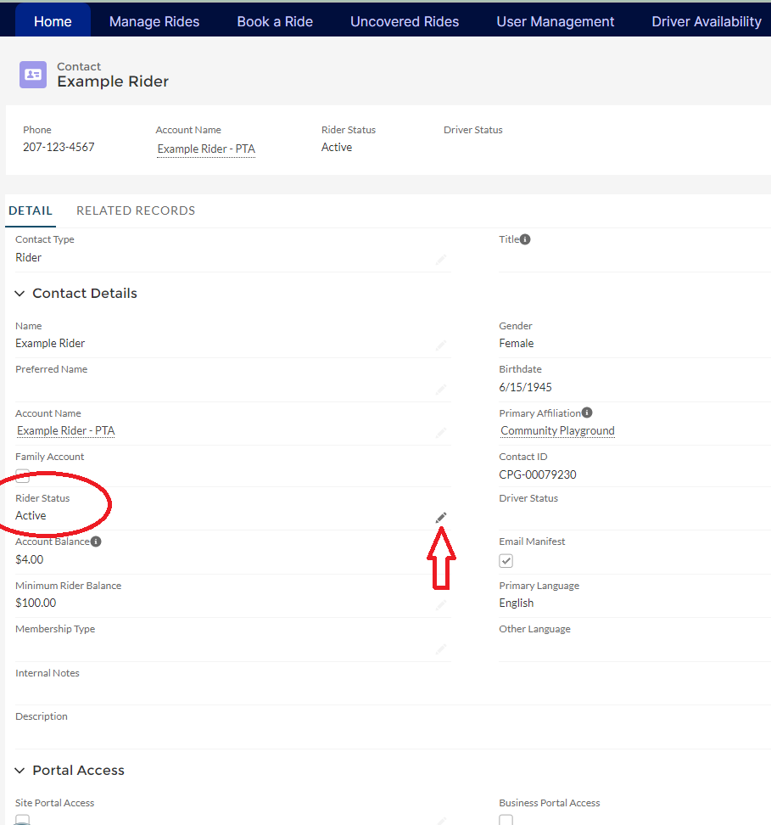

Once you click the pencil, the screen becomes editable.

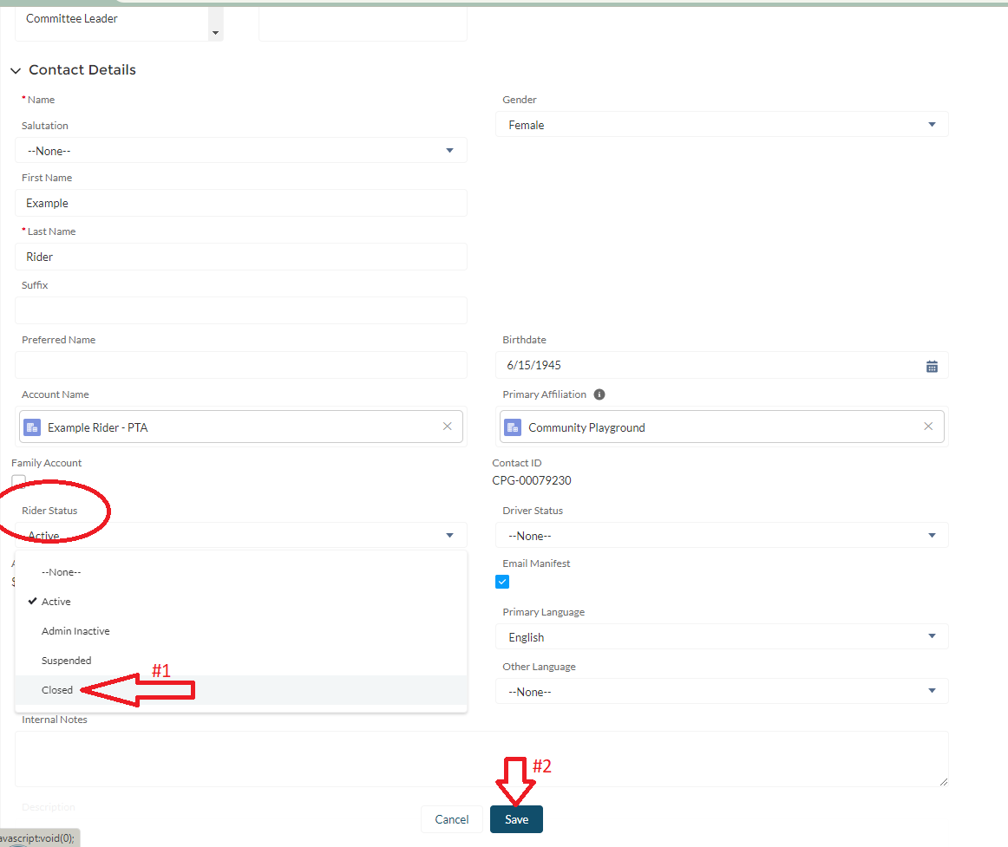

1. Once you close the account, you must also cancel the recurring membership charge if applicable. Go to the Related Records, and under Opportunities, find the Pledged Membership Charge. Change the Stage from Pledged to Closed/Lost.

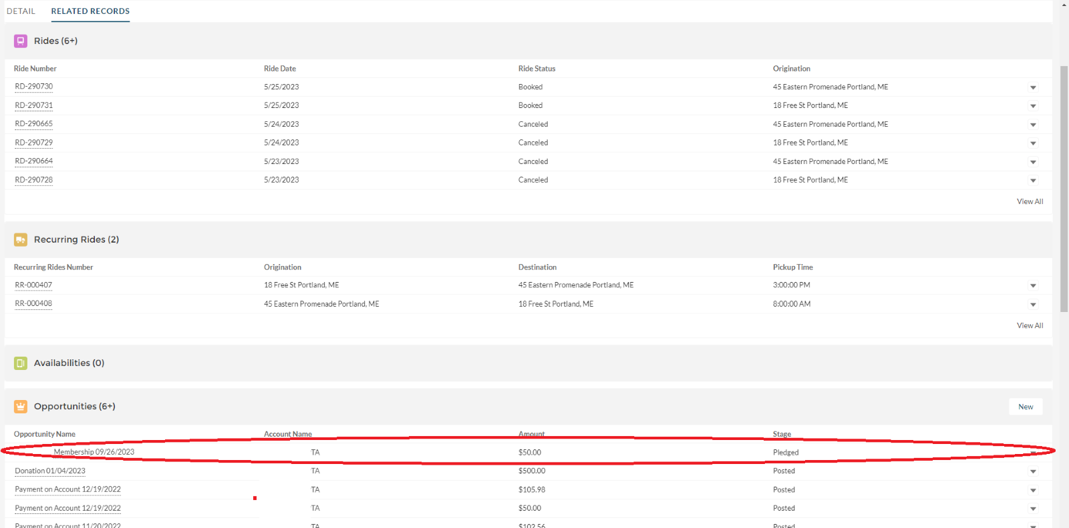

Click on the Opportunity Name to open the record.

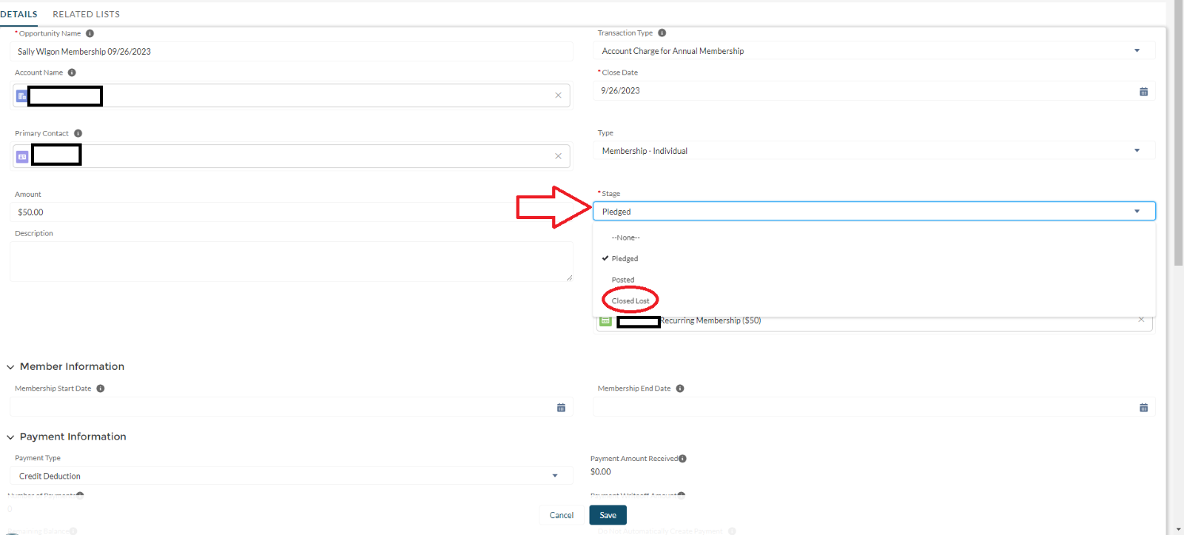

1. Click Save, and the Account is fully closed.