Closing an Account with a PTA Balance

1. Navigate to the rider’s Contact Record, and note the balance of the account.

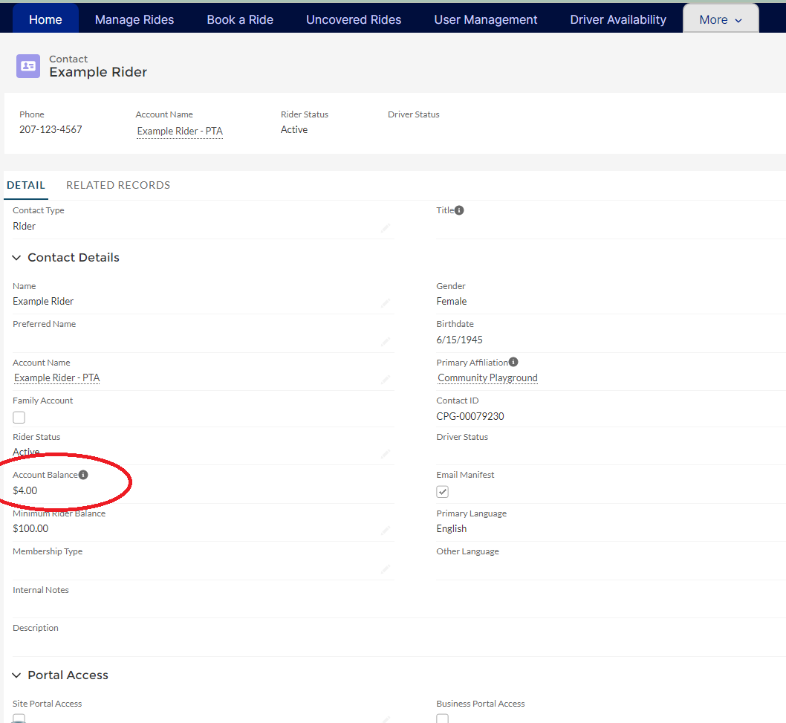

1. Select the quick action button “New Account Adjustment” under the arrow near the top right. (This option is equivalent to the non-cash transactions from ITNRides 1.5). This provides several options for zeroing out the rider’s balance.

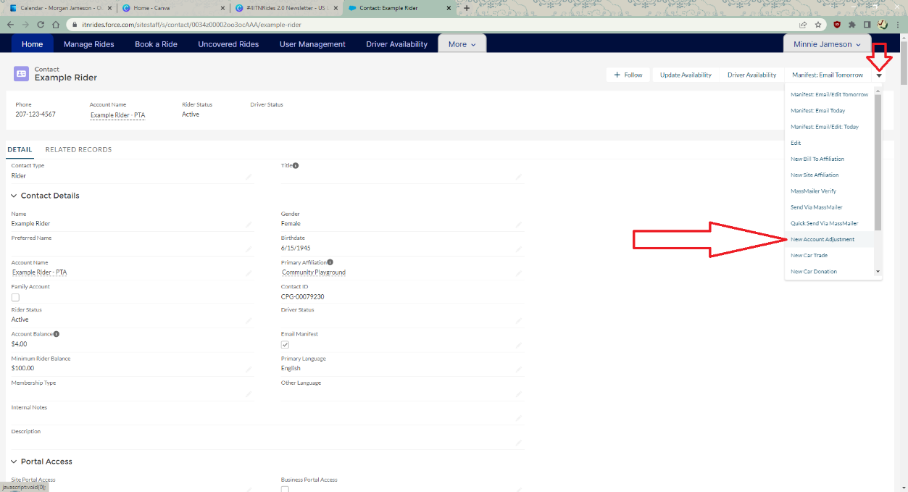

1. Complete the pop-up form that opens, selecting the appropriate Transaction Type from the drop-down list. Then click Save.

* 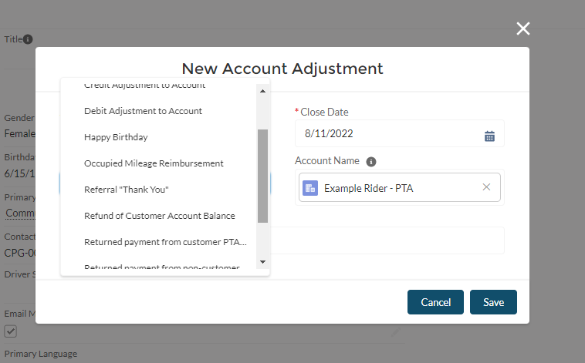
* (Account Adjustment Screen with Transaction Types Menu open)
* 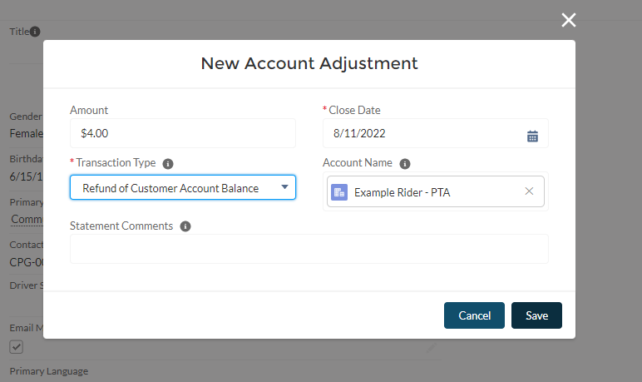
* (Account Adjustment Screen Filled In Example)

1. Once you Save the Adjustment, the screen will return to the Contact Record. The balance will appear the same, as financial transactions are processed overnight. Change the Rider Status from Active to Closed, and click Save. The account is now closed.

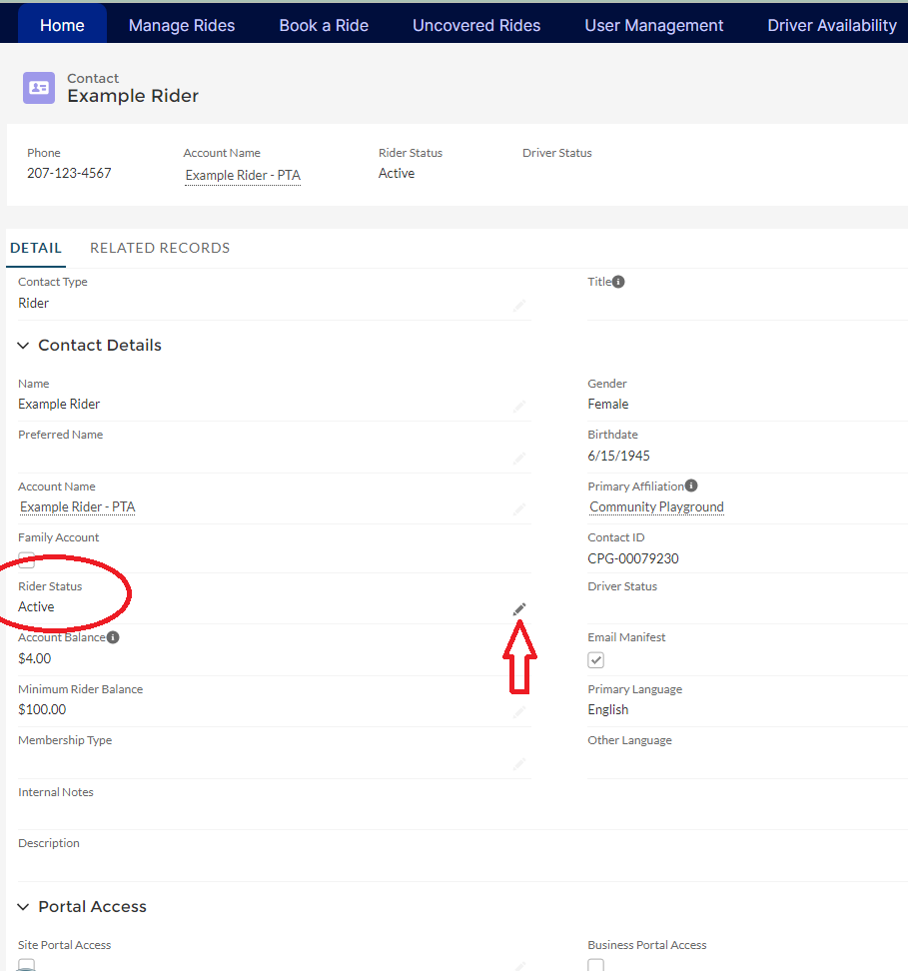

Once you click the pencil, the screen becomes editable.

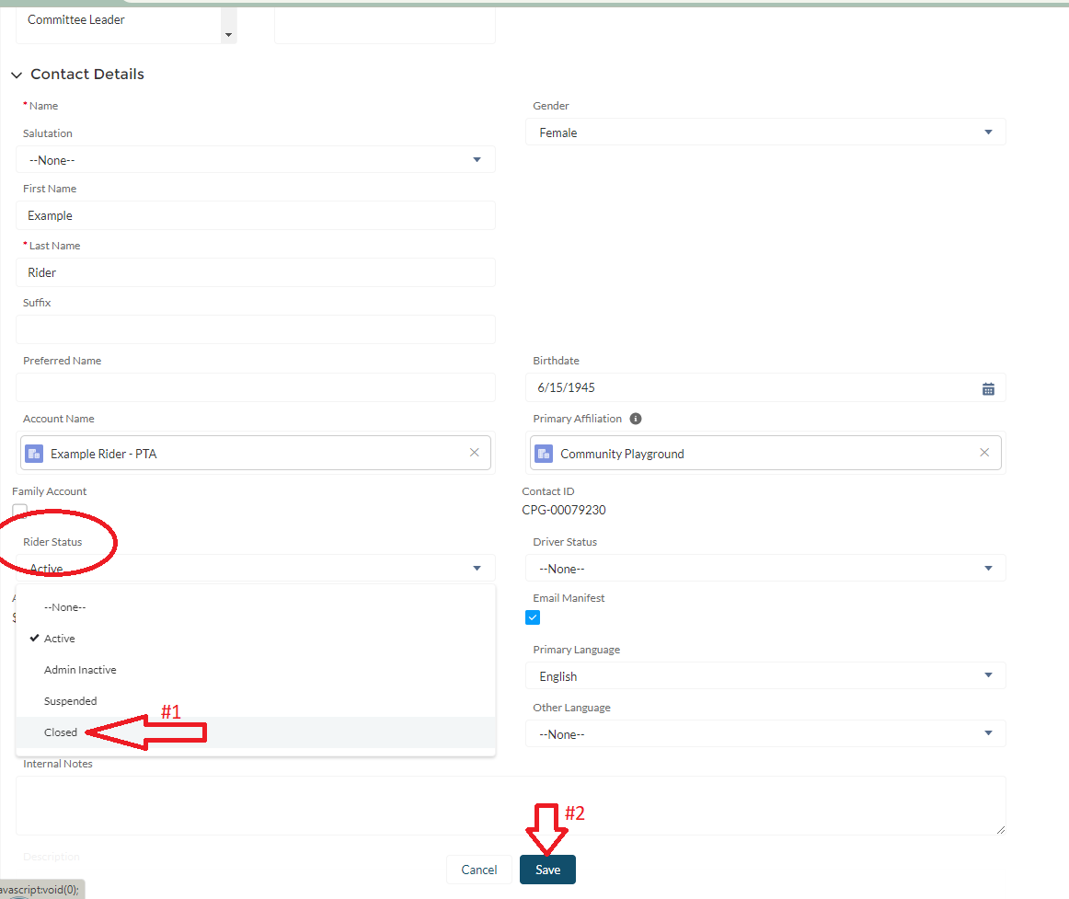

1. Once you close the account, you must also cancel the recurring membership charge. Go to the Related Records, and under Opportunities, find the Pledged Membership Charge. Change the Stage from Pledged to Closed/Lost.

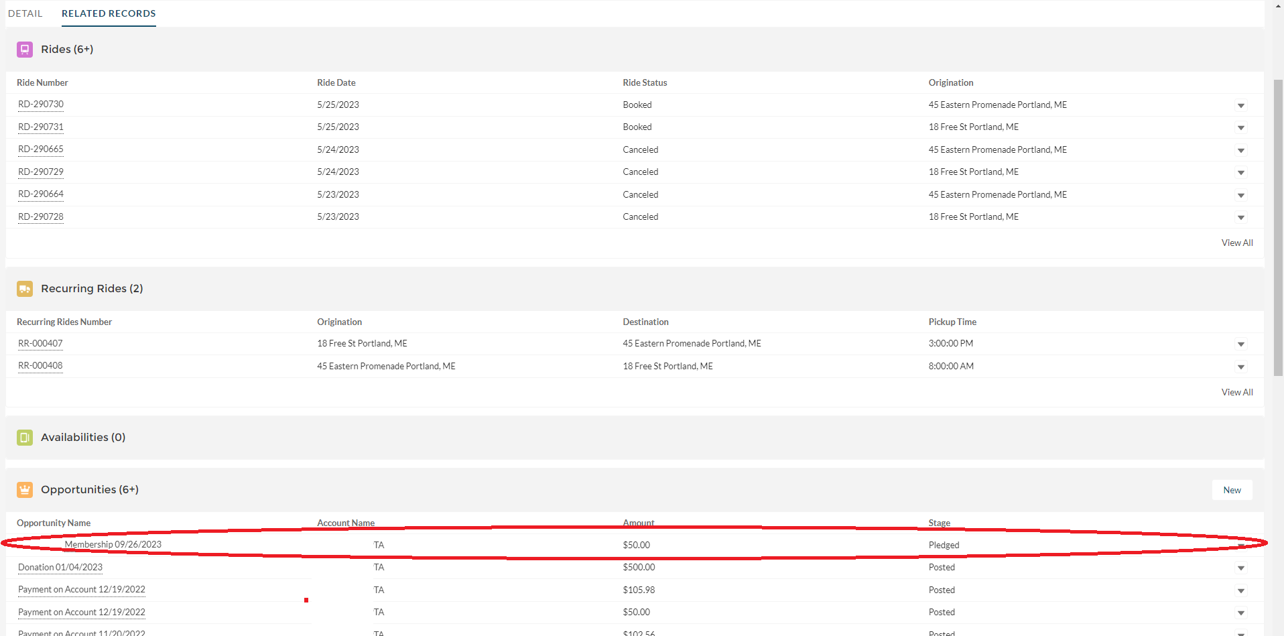

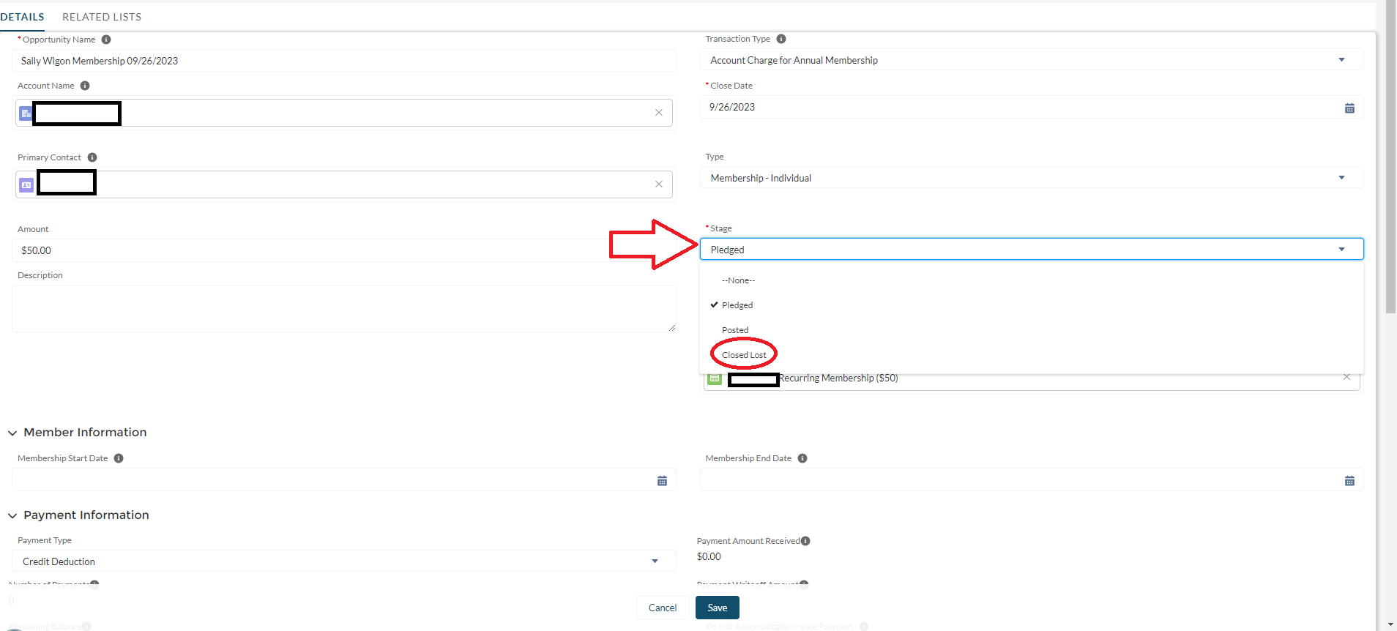

1. The Account is now closed.